LooP Demo

Video is at <https://youtu.be/d7Dx4cSsvMM>

1. Start our program
   1. Start Visual Studio
   2. Create a new empty C++ project:
   3. Call it “LoopDemo”, pick the desktop as the location and click OK.
   4. Click on Source Files and Add|New Item:

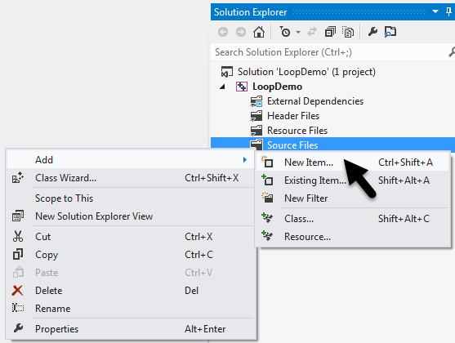

* 1. Select Visual C++, C++ File (.cpp), call it “LoopDemo”, then click “Add”:

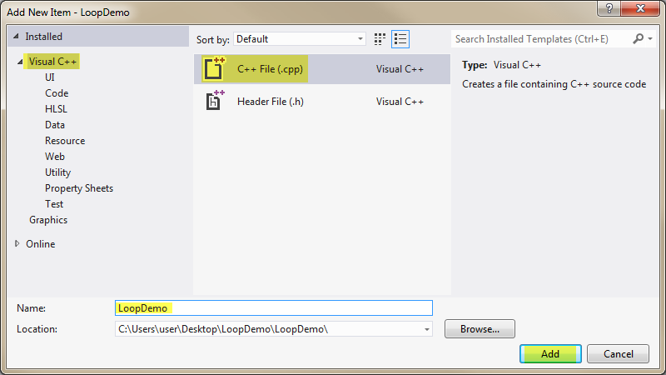

* 1. Enter the following code to start our program:

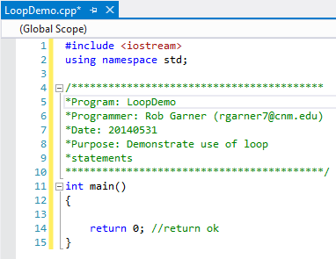

1. While Loop
   1. Replace the code with the following:

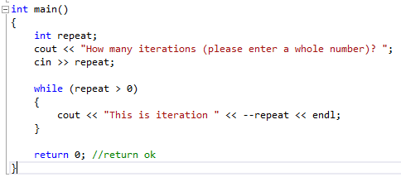

* 1. Try it with Ctrl-F5:

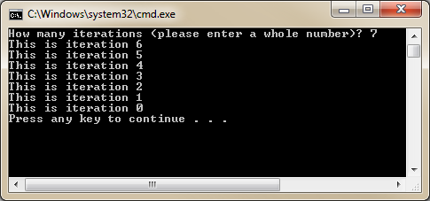

* 1. Why does this start with 6 and end with 0?
  2. Set a break point and run in debug mode to see how it runs.
  3. What if we changed --repeat to repeat--? Try it.

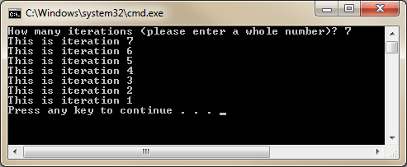

* 1. What happens if we enter 0 at the prompt? How many times does it run?

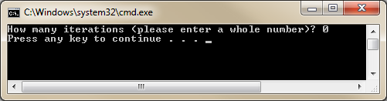

1. Do while loop:
   1. Change the code to:

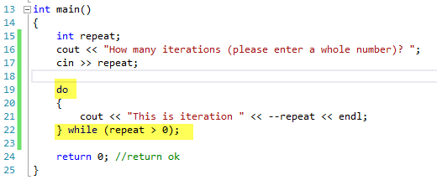

* 1. Try it with Ctrl-F5:

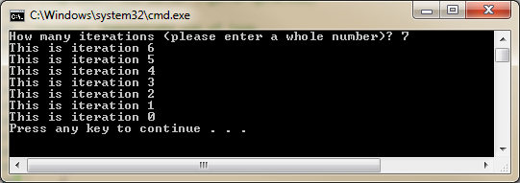

* 1. Notice it runs the same as a while loop.
  2. Now enter 0:

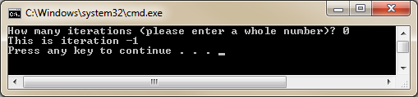

* 1. Why does it show iteration -1?
  2. Do while loops will always execute at least one iteration. It’s important to take this in account when picking whether or not to use a do while loop or a while loop.
  3. Change the code as follows:

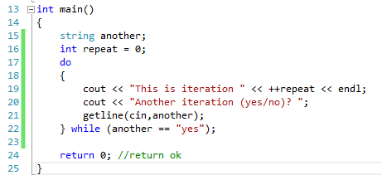

* 1. Try it with Ctrl-F5:

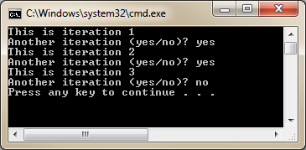

* 1. This is a more common use of the do while loop. This version of the code can be used when you want to offer the user the opportunity to run your program multiple times.

1. Demo for next loop:
   1. Add the following code:

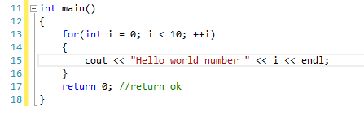

* 1. Try it with Ctrl-F5:

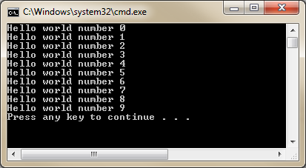

* 1. Notice that i starts at 0 and ends at 9. Why is this?
  2. Set a break point and step through the code in debug mode to see how it works.

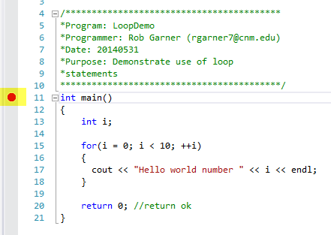

* 1. Start Debugging

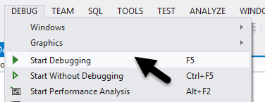

* 1. Select DEBUG|Step Over or F10 to step through the code:

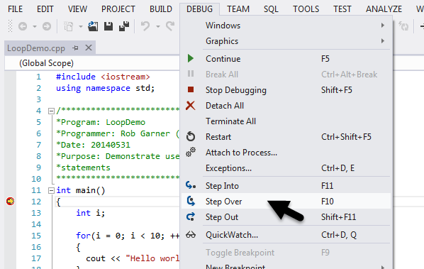

* 1. Watch the locals window typically located at the bottom of visual studio to see how the value of i changes:

